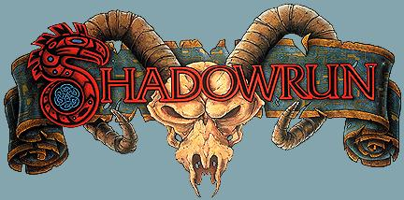

Stephen’s Armour Examples

Armoured Long Coat Extreme (Loose Fitting, Concealed Armour 3/2/2)
Location | Ballistic | Impact | Plates | Encumbrance Factor | Concealment Factor | Armour Value | Cost
Torso | 3 | 1 | 2 | 5 | 6 – 3 = 3 | 5/3 | 1,922
Arms | 4 | 2 | 0 | 4 | 5 – 2 = 3 | 4/2 | 924
Legs | 4 | 1 | 0 | 3 | 4 – 2 = 2 | 4/1 | 882
 |  |  |  | 12 | 3+(3+2/2)=5  (C: 14-5= 9 ) | 6/3 | ¥3,728

Form Fitting Body Suit Extreme (Form Fitting, Concealable Armour 1/each)
Location | Ballistic | Impact | Plates | Encumbrance Factor | Concealment Factor | Armour Value | Cost
Torso | 4 | 2 | 0 | 4 | 5/2 – 1 = 2 | 4/2 | 720
Arms | 4 | 2 | 0 | 4 | 5/2 – 1 = 2 | 4/2 | 720
Legs | 4 | 2 | 0 | 4 | 5/2 – 1 = 2 | 4/2 | 720
 |  |  |  | 12 | 2+(2+2/2)= 4  (C:14-4= 10 ) | 5/3 | ¥2,160
Max  EF | Equation | CP Loss
4 | 12–4=8/2 | 4
6 | 12–6=6/2 | 3
8 | 12–8=4/2 | 2
10 | 12–10=2/2 | 1
12 | 12–12=0/2 | 0
Combat Pool Loss Table
Stacked:
Location | Stacking | Eff. Armour | EF | Conc.
Torso | 5 / 3 + 4 / 2 | 7 / 4 | 6 / 0 | -
Arms | 4 / 2 + 4 / 2 | 6 / 3 | 5 / 0 | -
Legs | 4 / 1 + 4 / 2 | 6 / 2 | 4 / 0 | -
Total | 6 / 3 + 5 / 3 | 9 / 5 | 12 / 0 | 9 / 10

Cost: ¥5,888

